**Reading HTML Form Data – Overview**

**Reading HTML Form Data**:

Here we read form data with Spring MVC. So, at a high level, we have a form, we are going to prompt the user for there name. After that hit the Submit Button. It will go throw our Spring MVC application, and then will show a confirmation page.

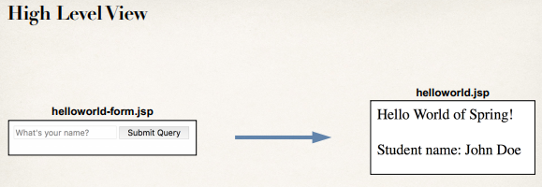

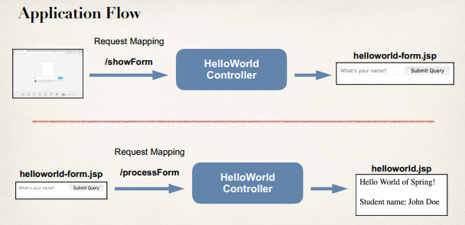

**Controller Class**:

@Controllerpublic class HelloWorldController { // need a controller method to show the initial HTML form @RequestMapping("/showForm") public String showForm() { return "helloworld-form"; }

// need a controller method to process the HTML form @RequestMapping("/processForm") public String processForm() { return "helloworld"; }}

Development Process

1. 1.Create Controller class
2. Show HTML form
   1. Create controller method to show HTML Form
   2. Create View Page for HTML form
3. Process HTML Form
   1. Create controller method to process HTML Form
   2. Develop View Page for Confirmation

Reading HTML Form Data - Overview